

Course Title: Machine Learning – (LAB)
Course Code: 032602434
Project Title: Smart House Price Prediction
Using Linear Regression and Decision Tree

Submitted By:
Muhammad Mustafa Ali – (67215)

Submitted To:
Mansoor Ahmed

OPEN ENDED LAB / PROJECT (OEL-1)

Table of Contents

1. TITLE 3
2. PROBLEM STATEMENT 3
3. CONCEPT 3
3.1 Linear Regression 3
3.2 Decision Tree Regressor 3
4. DESIGN 3
4.1 Input 3
4.2 Process 3
4.3 Output 3
5. LIBRARIES USED 4
6. SOURCE CODE 4
6.1 Linear Regression Notebook 4
6.2 Decision Tree Notebook 4
7. OUTPUT 5
7.1 EDA 5
7.2 Linear Regression 6
7.3 Decision Tree 7
8. ANALYSIS OF RESULTS 8
9. COMPARISON OF RESULTS 8
10. FUTURE WORK 9
11. CONCLUSION 9

1. TITLE
House Price Prediction Using Linear Regression and Decision Tree

2. PROBLEM STATEMENT
The objective of this project is to develop a machine learning model that can accurately predict house prices based on various features such as area, number of bedrooms, location score, distance from the city, and available facilities. The goal is to analyze the dataset, apply regression algorithms, and compare their performance to determine the most suitable model.

3. CONCEPT
This project uses Supervised Learning (Regression) because the target variable (house price) is continuous.

3.1 Linear Regression
- Used because it models relationships between variables in a linear way
- Suitable for datasets where features have a direct proportional impact on the target
- Simple, fast, and interpretable

3.2 Decision Tree Regressor
- Used to capture non-linear relationships
- Works by splitting data into smaller subsets
- Useful when relationships are complex and not strictly linear

4. DESIGN

4.1 Input
Dataset containing multiple features such as Area (in square feet), Number of Bedrooms, Location Score, Distance from City Center, and other relevant attributes that influence house pricing. These features act as independent variables for the models.

4.2 Process
- Data analysis (EDA) to understand patterns, relationships, and distributions within the dataset
- Data preprocessing such as cleaning, handling missing values, and scaling (if required)
- Model training using machine learning algorithms (Linear Regression and Decision Tree Regressor)
- Prediction of house prices based on learned patterns from the training data

4.3 Output
- Predicted house prices generated by the trained models
- Performance metrics such as R² Score and RMSE to evaluate model accuracy
- Visualization outputs like Actual vs Predicted plots and residual graphs to assess model performance visually

5. LIBRARIES USED
The following Python libraries were used in this project:
NumPy
- Used for numerical computations and handling arrays
- Helps in generating random data and performing mathematical operations
Pandas
- Used for data manipulation and analysis
- Helps in creating and managing the dataset in tabular form
Matplotlib
- Used for basic data visualization
- Helps in plotting graphs such as scatter plots and histograms
Seaborn
- Built on top of Matplotlib for advanced visualizations
- Used for creating correlation heatmaps and better-looking graphs
Scikit-learn (sklearn)
- Used for implementing machine learning models
- Provides tools for:
- Linear Regression
- Decision Tree Regressor
- Train-test splitting
- Evaluation metrics (MSE, RMSE, R²)

6. SOURCE CODE

6.1 Linear Regression Notebook

6.2 Decision Tree Notebook

7. OUTPUT

7.1 EDA
The Exploratory Data Analysis (EDA) provides important insights into the dataset.
The correlation heatmap shows that Area_sqft has the strongest positive correlation with house price (≈ 0.67), followed by Location_Score (≈ 0.58). Facilities_Score also has a moderate positive impact (≈ 0.35), while Distance_from_City_km has a negative correlation (≈ -0.17), indicating that houses farther from the city tend to have lower prices.
The distribution plots show that most features are evenly spread, while house prices follow a roughly normal distribution centered around mid-range values. This indicates that the dataset is well-balanced and suitable for modeling.
The scatter plots further confirm relationships:
- Area vs Price shows a strong linear upward trend
- Location Score vs Price also shows a clear positive trend
- Bedrooms vs Price shows a moderate relationship with some spread
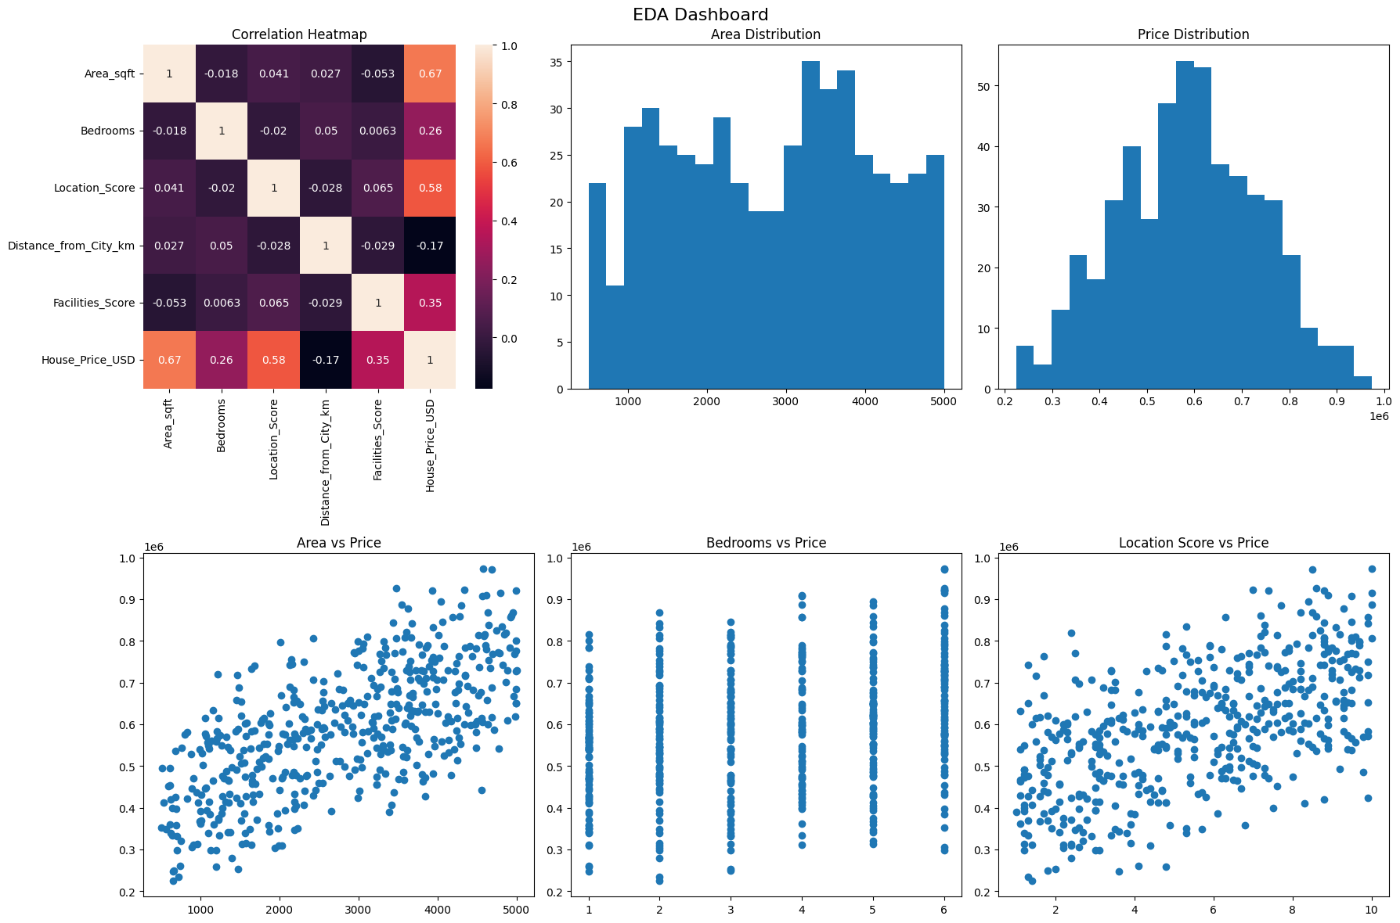

7.2 Linear Regression
The Linear Regression model performs extremely well on this dataset.
The Actual vs Predicted plot shows that most data points lie very close to the diagonal line, indicating highly accurate predictions. The model is able to capture the relationship between features and house price effectively.
The Residual plot shows that errors are evenly distributed around zero with no clear pattern. This suggests that the model assumptions are satisfied and there is no major bias or underfitting.
The feature coefficients indicate that:
- Area_sqft has the highest positive impact on price
- Location_Score and Facilities_Score also contribute significantly
- Distance_from_City_km has a negative effect, which aligns with real-world expectations
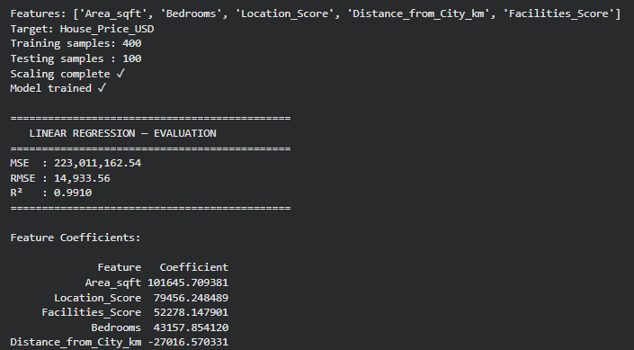
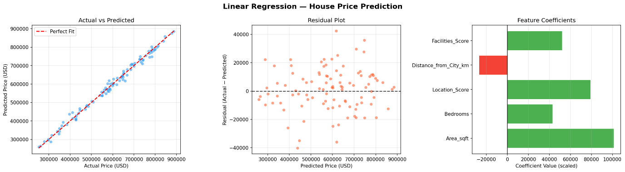

7.3 Decision Tree
The Decision Tree model also performs well but shows slightly lower accuracy compared to Linear Regression.
The Actual vs Predicted plot shows a wider spread of points around the diagonal line, indicating higher prediction errors.
The Residual plot shows larger variation in errors, suggesting that the model is less stable compared to Linear Regression.
The feature importance graph shows that:
- Area_sqft is the most important feature
- Location_Score is the second most influential
- Other features contribute less significantly
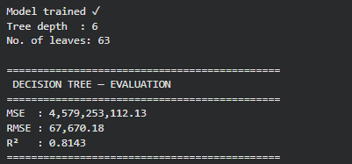
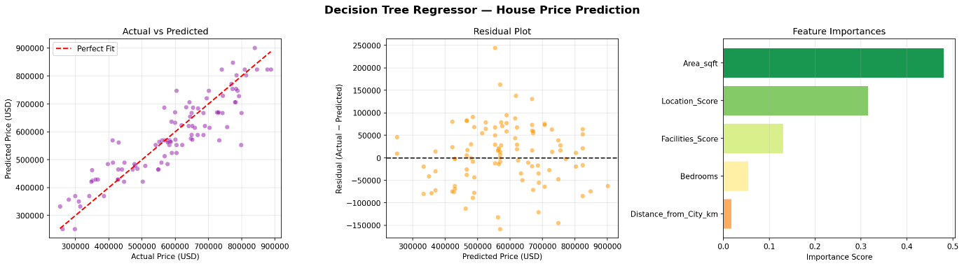
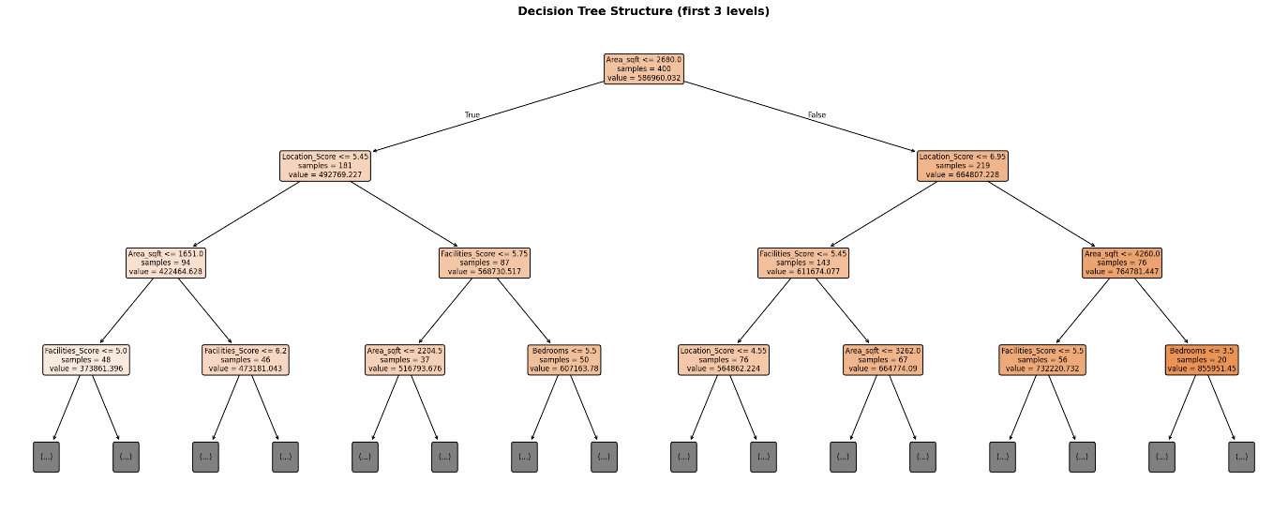

8. ANALYSIS OF RESULTS
Linear Regression achieved a high R² score and low RMSE, indicating strong predictive accuracy and minimal error. In contrast, the Decision Tree Regressor shows higher error and lower accuracy, with less precise predictions in the Actual vs Predicted plot.
Residual analysis supports this: Linear Regression residuals are evenly distributed around zero, showing a good fit, while Decision Tree residuals vary more, indicating instability.
Feature analysis shows Area_sqft as the most influential factor, followed by Location_Score. Distance_from_City_km negatively affects price, while Bedrooms and Facilities_Score have moderate impact.
EDA findings align with these results, showing strong correlations and linear trends, which explain the superior performance of Linear Regression.
- The dataset has a strong linear structure
- Linear Regression is well-suited
- Decision Tree is less effective due to over-segmentation

9. COMPARISON OF RESULTS
Linear Regression achieved a higher R² score and lower Mean Squared Error (MSE), indicating better accuracy and more reliable predictions. Its predictions closely follow the actual values, as seen in the Actual vs Predicted plot, where points lie near the ideal diagonal line.
In contrast, the Decision Tree Regressor has a lower R² score and higher MSE, reflecting reduced accuracy. Its predictions are more scattered, with greater deviation from the ideal line, indicating higher error.
Residual plots further support this comparison. Linear Regression residuals are small and randomly distributed, suggesting a well-fitted model. Decision Tree residuals show larger variation, indicating inconsistency in predictions.
 | Linear Regression | Decision Tree
R² | 0.9910 | 0.8143
MSE | 223,011,162.54 | 4,579,253,112.13
RMSE | 14,933.56 | 67,670.18
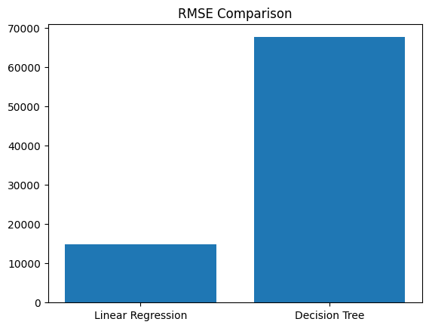
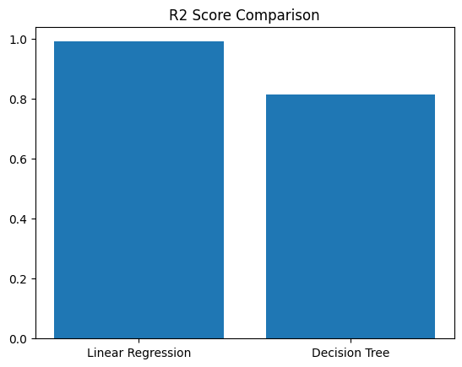

10. FUTURE WORK
This project can be further improved by using real-world datasets instead of synthetic data. More advanced models such as Random Forest and Gradient Boosting can be applied to improve prediction accuracy. Hyperparameter tuning and cross-validation can also be used to enhance model performance. Additionally, deploying the model as a web application can make it more practical and user-friendly.

11. CONCLUSION
This project demonstrates the use of machine learning techniques to predict house prices using a custom dataset. Through Exploratory Data Analysis (EDA), key patterns were identified, especially the strong impact of area and location on price.
Two models, Linear Regression and Decision Tree Regressor, were evaluated using R² score and RMSE. Linear Regression performed better, providing more accurate and consistent predictions.
The results show that model performance depends on the dataset. Since the data follows a linear trend, Linear Regression was more suitable, while the Decision Tree added unnecessary complexity.

